G4 house, Kilakala Bong’ola, Morogoro

Furnished Rooms, Apartments and Conference facility

Our Motto: ‘To provide you service that makes you feel at home, safe and productive, away from home’

About Us
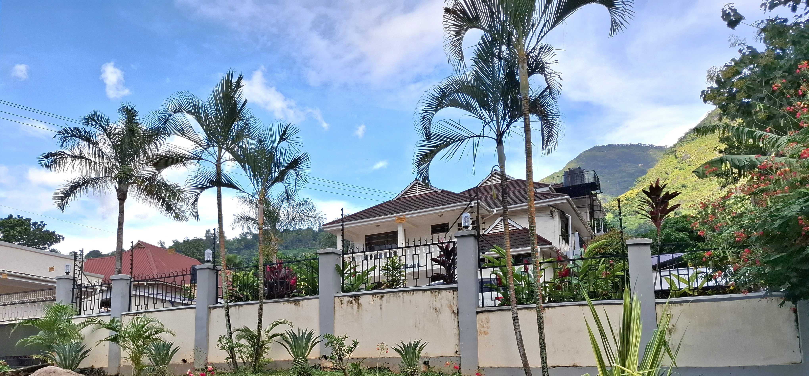
Nestled in the serene mountain scenery of Kilakala, G4 House offers the perfect blend of comfort, tranquility, and convenience. Whether you’re traveling for business or leisure, our peaceful setting provides an ideal retreat away from the bustle of everyday life.
Combining an exclusive location with reliable accommodation and well-equipped conference facilities, G4 House is a preferred choice for both business and leisure travelers. We take pride in delivering personalized service, ensuring every guest enjoys privacy, quality, and exceptional value for money.
Over time, G4 House has built a strong reputation for creating a welcoming and memorable experience—where comfort meets attentive hospitality.

Accommodation
Enjoy the comfort of our fully furnished, spacious rooms and apartments, each thoughtfully designed to make you feel at home. Every room features a private bathroom, fresh bed linen, and soft towels for your convenience. Relax with a 43” smart TV, stay connected with free Wi-Fi, and take in the calming views of the Uluguru Mountains—perfect for unwinding and recharging.
Our rooms are tastefully and modernly decorated for single or double occupancy, with a personal touch that blends comfort and style. Each room maintains impeccable hygiene standards and includes full air-conditioning and private balcony access for added comfort and privacy. We also offer affordable rates, allowing you to enjoy a quality stay without stretching your budget.

The Compound
A standout feature of our facility is its neat and well-maintained environment, beautifully enhanced by a vibrant flower garden. Guests can enjoy the refreshing outdoor atmosphere—perfect for relaxation or casual business meetings—on our thoughtfully designed terraces.
We offer free parking for all resident guests. At G4 House, your safety and security are a top priority. The property is equipped with fire extinguishers in common areas, external CCTV surveillance, smoke alarms, a security alarm system, and 24-hour security to ensure complete peace of mind.

Location
One of the most distinctive features of G4 House is its prime location in Kilakala, Morogoro. Situated just 5 km from the busy and congested streets of central Morogoro, we offer a modern and comfortable setting—ideal for privacy, work retreats, team stays, and individual travelers seeking tranquility, whether for business or relaxation.
Our location provides convenient access to the city via Bolt and other transport services, while still allowing you to enjoy a calm and refreshing environment away from the hustle and bustle.
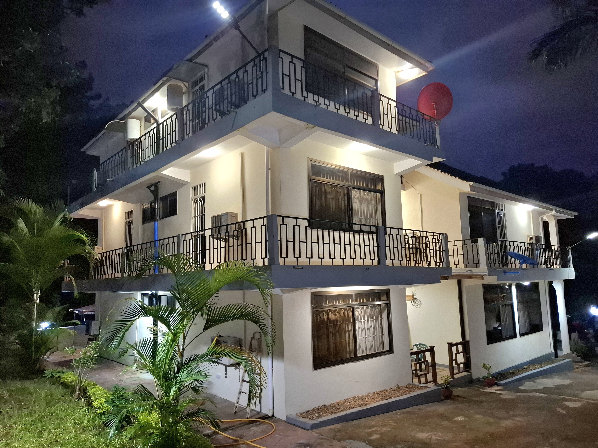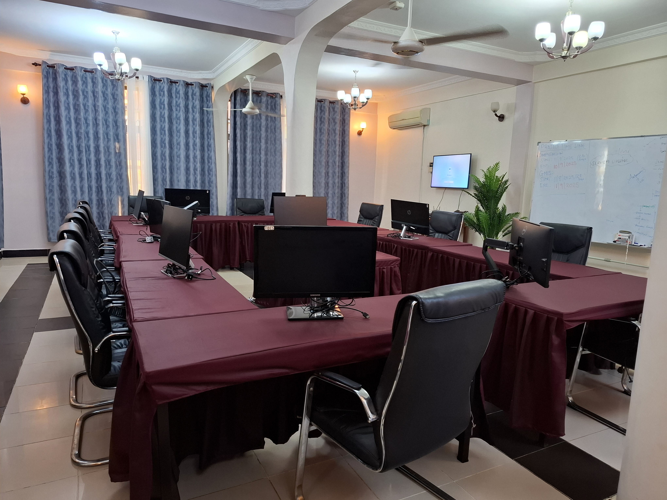

Conference Facility
We offer an exclusive conference facility designed for small to medium-sized teams of up to 25 participants, providing a comfortable and productive environment for meetings and events.
To enhance convenience, conference participants can stay in our modern, well-appointed rooms, allowing teams to work efficiently without interruptions or the need to travel between venues. This seamless setup supports longer, more focused working sessions.
Guests enjoy direct access to the conference area at any time, along with high-speed internet, ample parking, a 24-hour front desk, and our on-site bar and restaurant—ensuring all needs are met in one place.

